**Lab 5: Android TableLayout**

# **Introduction**

In Table layout views are groups in rows and columns. <TableRow> is used to add a row in this layout Each view is placed in a cell.

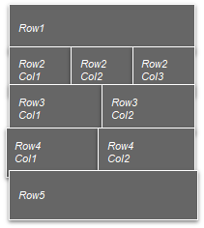

**Let’s get Started**

You will be guided through easy stages in this exercise to design your own Android application utilising a table structure. **Step 1: Create a New Project in Android Studio as shown below**

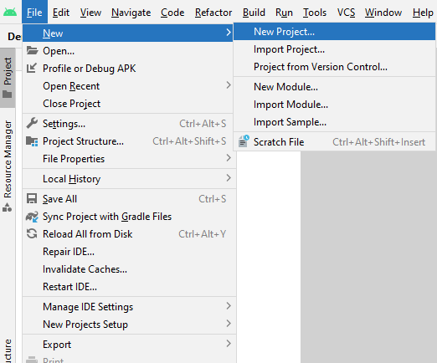

**Step 2: Select Empty Activity as shown below**

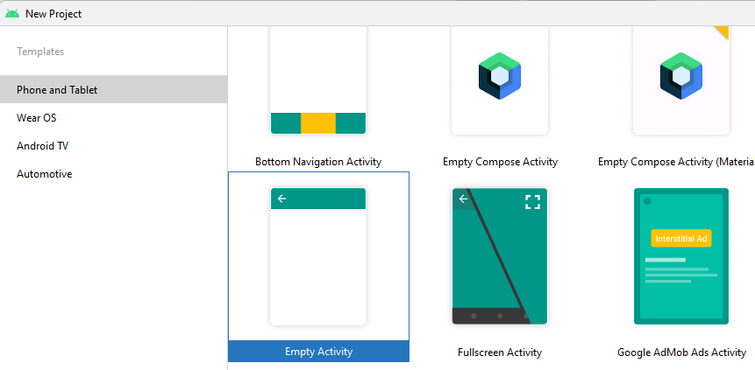

**Step 3: Provide a Project Name as shown below**

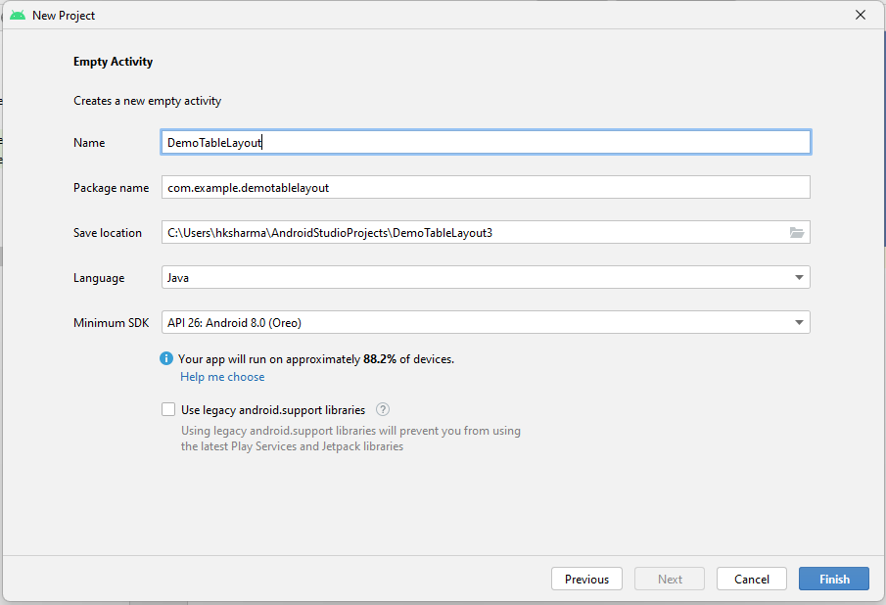

**Step 4: Update MainActivity.java as per the code given below**

**package** com.example.demotablelayout;  
**import** androidx.appcompat.app.AppCompatActivity;  
**import** android.os.Bundle;  
**public class** MainActivity **extends** AppCompatActivity {  
  
 @Override  
 **protected void** onCreate(Bundle savedInstanceState) {  
 **super**.onCreate(savedInstanceState);  
 setContentView(R.layout.***activity_main***);  
 }  
}

**Step 5: Update activity_main.xml as per the code given below**

*<?***xml version="1.0" encoding="utf-8"***?>*<**TableLayout xmlns:android="http://schemas.android.com/apk/res/android"  
 android:layout_width="fill_parent"  
 android:layout_height="fill_parent"**>  
  
 <**TableRow  
 android:layout_width="fill_parent"  
 android:layout_height="fill_parent"**>  
  
 <**TextView  
 android:text="Time"  
 android:layout_width="wrap_content"  
 android:layout_height="wrap_content"  
 android:layout_column="1"** />  
  
 <**TextClock  
 android:layout_width="wrap_content"  
 android:layout_height="wrap_content"  
 android:id="@+id/textClock"  
 android:layout_column="2"** />  
  
 </**TableRow**>  
 <**TableRow**>  
 <**TextView  
 android:text="Your Name"  
 android:layout_width="wrap_content"  
 android:layout_height="wrap_content"  
 android:layout_column="1"** />  
  
 <**EditText  
 android:width="200px"  
 android:layout_width="wrap_content"  
 android:layout_height="wrap_content"** />  
 </**TableRow**>  
  
 <**TableRow**>  
 <**TextView  
 android:text="Your Age"  
 android:layout_width="wrap_content"  
 android:layout_height="wrap_content"  
 android:layout_column="1"** />  
  
 <**EditText  
 android:width="100px"  
 android:layout_width="wrap_content"  
 android:layout_height="wrap_content"** />  
 </**TableRow**>  
  
 <**TableRow  
 android:layout_width="fill_parent"  
 android:layout_height="fill_parent"**>  
  
 <**Button  
 android:layout_width="wrap_content"  
 android:layout_height="wrap_content"  
 android:text="Submit"  
 android:id="@+id/button"  
 android:layout_column="2"** />  
 </**TableRow**>  
  
 <**TableRow  
 android:layout_width="fill_parent"  
 android:layout_height="fill_parent"**/>  
  
 <**TableRow  
 android:layout_width="fill_parent"  
 android:layout_height="fill_parent"**>  
  
 <**Button  
 android:layout_width="wrap_content"  
 android:layout_height="wrap_content"  
 android:text="Cancel"  
 android:id="@+id/button"  
 android:layout_column="2"** />  
 </**TableRow**>  
  
</**TableLayout**>

**Step 6: Check Output on Android Emulator and it should look like as given below**

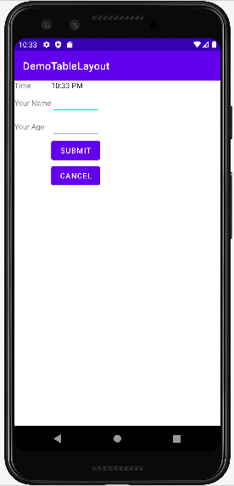

**Voila!!** We have successfully completed this lab.